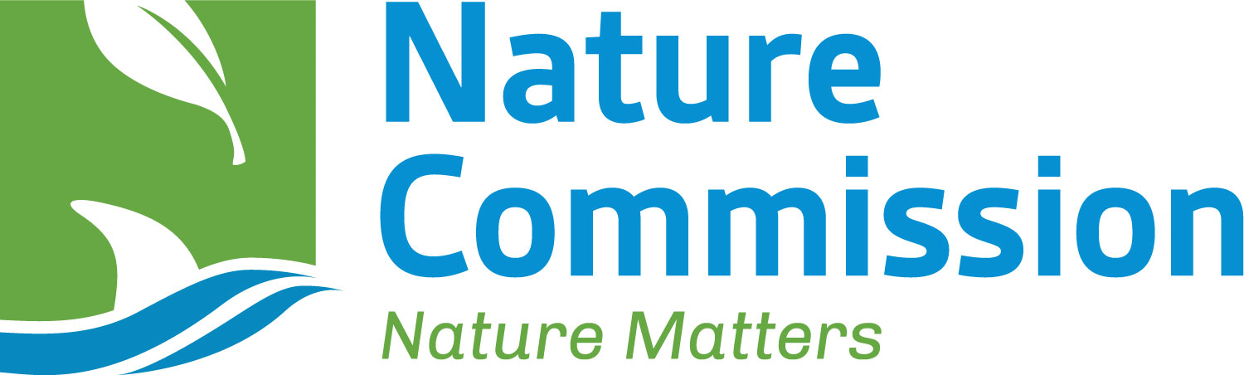
Nature Opportunities for Businesses
PROJECT APPLICATION FORM
If you would like to add a project or projects led by your organisation to the Nature Commission’s ‘Nature Opportunities for Businesses’ initiative, please complete the below application form with the project details. A separate form for each project will be required. To ensure your organisation and project is eligible, please refer to the Eligibility Criteria available on the application page of the website.
Please complete all sections of this form. You may attach any additional supporting information as relevant to your application, however, please ensure that all key information is included on the form in the relevant sections.

Project title
This will be displayed on the website.

Project blurb
Max. 20 words. This is the text that will be displayed before the project is clicked into to provide more details. This text should be a short, sharp way to outline the project, encouraging the reader to click on this project to find out more. A sound bite.

Project description
Max. 50 words. This is the initial text that will tell the reader what the project is about, encouraging them to continue reading for more detail.

Project overview
Please provide the following: what is the project? Why is it needed? How will allocated funds be spent? Project so far (N/a for new projects). Any other relevant content. This content will be displayed on the website.

Funding amount required by project
This amount can either be the full amount for the project in its entirety, or for a portion or phase of the project. Whichever it is for, please ensure that the project description is related to this. For example, if the funding amount you state here is for a phase, the project description should note which phase of the project is being promoted. This content will be displayed on the website.

What are the anticipated and/or evidenced outcomes of the project?
See other projects for examples and outcome styles. This content will be displayed on the website.

Logo relevant to the project
Please provide a high-resolution version of your organisation’s logo. If you have a project specific logo, please provide a high-resolution version of both the project logo and the organisation logo. This content will be displayed on the website.
Mark box if provided ☐

Photos/ images relevant to the project
Please provide a minimum of two images. If you have a preference for which image is the front-page project display image, please note this. The organisation and/ or project logo (see above) can form one/ two of the images if preferred. This content will be displayed on the website.
Mark box if provided ☐

Goal(s) and objective(s) of the 2020 Strategy for Nature met by the project
This will help the Nature Commission to ensure that this project meets the eligibility criteria and can be used as a filter function on the website.

Driver(s) of change (based on State of Nature 2024) the project helps to address
See Chapter 7 of the full State of Nature 2024 report for drivers of change, and outline which of these pressures your project will help to address and how. This will help the Nature Commission to ensure that this project meets the eligibility criteria and can be used as a filter function on the website.

Location of the project
Please specify to parish level. If the project is not parish specific, please just note the island. This will help the Nature Commission to ensure that this project meets the eligibility criteria.

Which UN Sustainable Development Goals are contributed to through the project
This will be added to the filter function on the webpage to help businesses filter projects by UN SDGs. See link above which will take you to the Goals for more information.

Other relevant project links, e.g. YouTube video
Only include links if you would like them included in the project webpage.

Project timeline
If a new project, when is it due to commence? If an existing project, when did it commence? Please also provide a date for completion of the project – if there is no completion date as the project is ongoing with ongoing costs, please state this. This will ensure that only live projects that require funding are displayed and promoted through ‘Nature Opportunities for Businesses’.

Registered charity number of organisation leading the project
This will help the Nature Commission to ensure that this project meets the eligibility criteria

Blurb of organisation leading the project
Approximately 100 words to be displayed on the website.

Contact details for organisation leading the project
Please provide an email address which can be displayed on the website, so that you can be contacted about the project.

Location of organisation leading the project
This will help the Nature Commission to ensure that this project meets the eligibility criteria.

Links to website and social medias of organisation leading the project
This can include a project specific website and social medias if available, and/or the website and socials of the organisation leading the project. This content will be displayed on the website.

Any other information?
If there is any other information about the project that you would like to provide, or anything relevant to the project that you are aware of, please detail here. This content will be displayed on the website.

Confirmation that the organisation’s financial statements are available:
On organisation’s website ☐ On Guernsey Registry ☐ Not publicly available ☐ Available on request ☐

Promotion
Would you be happy to update the Nature Commission with information and photographs once your project is underway, for use in publicity and promotional campaigns?
☐ Yes ☐ No
Would you like this project and associated information to be submitted to EcoMatch (a UK Overseas Territories Conservation Forum initiative in development, similar to ‘Nature Opportunities for Businesses’, but with a UK Overseas Territories audience)?
☐ Yes ☐ No
DECLARATION:
I declare that all the details completed in this application form are correct and accurate to the best of my knowledge, and that I understand the nature of the application and the particulars being asked.
Signature
Name
Date
DATA PROTECTION:
This information will be treated with the strictest confidence. Personal information provided on this form is protected and used in accordance with the Data Protection (Bailiwick of Guernsey) Law, 2017. Information provided will be used only for the purposes of the ‘Nature Opportunities for Businesses’ initiative, and for the purpose of compliance with any applicable regulations. The Nature Commission Fair Processing Notice is available on the website.
PLEASE RETURN COMPLETED APPLICATION FORMS TO: office@naturecommission.gg

